AIN SHAMS UNIVERSITY  FACULTY OF ENGINEERING  International Credit Hour Engineering Programs (ICHEP)  Computer Engineering and Software Systems Program (CESS) | 
CSE351 / CSE361
Computer Networks



Mini RFC

Team 25

 | 

AIN SHAMS UNIVERSITY

FACULTY OF ENGINEERING

International Credit Hour Programs (ICHEP)
Computer Engineering and Software Systems Program (CESS)
Computer Networks
Multi-Player Game State Synchronization
 | Team 25
Done by: | Ahmed Hazem Khalil | 22P0226
 | Karim Hatem | 22P0153
 | Ahmed Aabdallah Nofull | 22P0255
 | Mohamed Amir Kamal | 2301144
 | Youssef Maged Mores | 2301081
 | Marwan Wagih Mohamed | 23P0247
Delivered to: |  | Dr. Karim Emara  Dr. Ayman Bahaa Eldin
 |  | Eng. Mina

Table of Contents
1.0 Introduction 3
2.0 Protocol Header Format 3
2.1 Entities 3
2.2 Data Flow 4
2.3 Sequence Flow 5
2.4 Client Finite State Machine 6
3.0 Message Types 7
4.0 Communication Procedures 7
4.1 Session Start (Connection Establishment) 7
4.2 Normal Data Exchange 7
4.3 Error Recovery 7
4.4 Shutdown 7
5.0 Reliability & Performance Features 8
5.1 Selective Reliability Model 8
5.2 Retransmission Strategy 8
5.3 Delta Compression & Bandwidth Optimization 8
5.4 Sequence Manager & Sliding Window 8
6.0 Experimental Evaluation Plan 8
6.1 Baseline Execution 8
6.2 Network Impairment Simulation (Linux NetEm) 9
6.3 Metrics Collected 9
6.4 Automation 9
7.0 Example Use Case Walkthrough 10

Table of Figures
Figure (1): Data Flow 4
Figure (2): Sequence Flow 5
Figure (3): Client Finite State Machine 6
Figure (4): Netem Output 9
Figure (5): Server Log Output 10
Figure (6): Wireshark Screenshot 10

MINI RFC 2025-GUDP: Real-Time Grid Clash Protocol Specification
Status: Experimental
Version: 2.0
Date: December 2025
Author: Team 25

1.0 Introduction
The GridClashSync _{phase one} protocol (also referred to as Gaming User Datagram Protocol (GUDP) _{phase two}) is a custom application-layer protocol designed for real-time multiplayer game state synchronization in the Grid Clash environment. It operates over UDP to minimize latency while implementing selective reliability for critical game events. The protocol follows an authoritative server architecture with client-side prediction, delta compression, and jitter compensation.

Core Design Constraints
- UDP transport (no TCP retransmissions)
- Total packet size ≤ 1200 bytes
- Target end-to-end latency ≤ 50 ms
- Supports up to 4 concurrent clients
- Operates correctly under 2–5% packet loss

Evolution from Phase 1 to Phase 2
Phase 1 focused on a basic UDP-based sync mechanism with minimal reliability. Phase 2 introduced selective reliability, delta compression, and enhanced header fields to improve performance under packet loss and reduce bandwidth usage.

2.0 Protocol Header Format
Every GUDP packet begins with a fixed 28-byte header utilizing Big-Endian byte order to ensure cross-platform compatibility. Checksum was added in phase 2.

2.1 Entities
- Server: the central authority responsible for keeping the authoritative grid state. It collects player actions, updates the global game map, and broadcasts periodic snapshots.
- Clients: individual player applications that send user actions (clicks or moves) to the server and apply the updates received in snapshots.

2.2 Data Flow

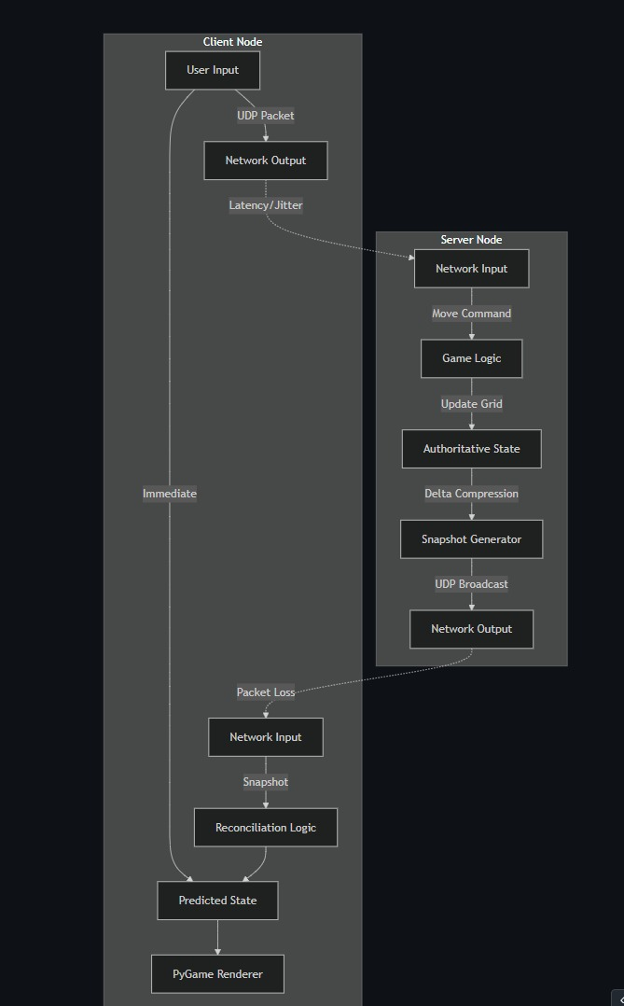
Figure (1): Data Flow

2.3 Sequence Flow
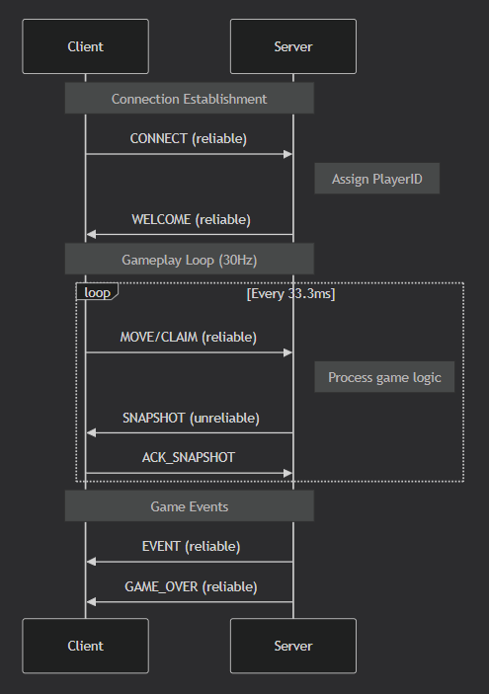
Figure (2): Sequence Flow

2.4 Client Finite State Machine

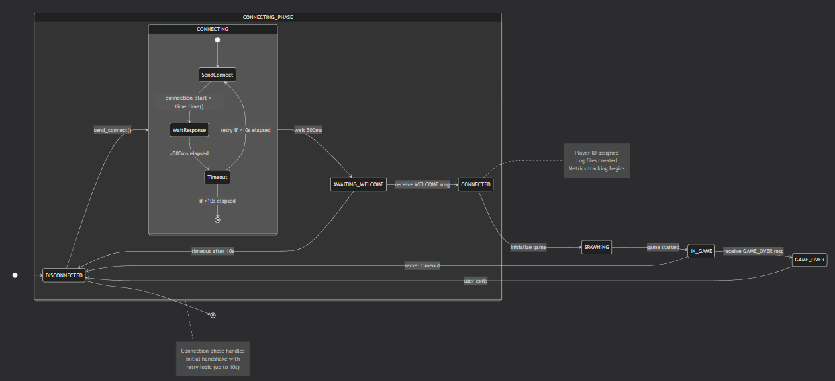
Figure (3): Client Finite State Machine

3.0 Message Types
Phase 1 defined 4 basic message types. Phase 2 expanded this to support richer gameplay and reliability mechanisms.
Offset (Bytes) | Field Name | Data Type | Python Fmt | Description | Justification
0-3 | PROTO_ID | char[4] | >4s | Literal b'GUDP' | Magic bytes to reject non-protocol traffic on the port.
4 | VERSION | uint8 | B | 2 | Allows backward compatibility if packet structure changes.
5 | MSG_TYPE | uint8 | B | Enum (0-14) | Identifies payload handler (e.g., Move vs. Snapshot).
6-9 | SNAPSHOT_ID | uint32 | I | Integer | Global game state counter. Used for delta encoding reference.
10-13 | SEQ_NUM | uint32 | I | Integer | Per-client sequence number for packet loss detection and ordering.
14-21 | TIMESTAMP | uint64 | Q | Integer | Unix timestamp (ms). Used for RTT/Latency calculation.
22-23 | PAYLOAD_LEN | uint16 | H | Integer | Size of the data following the header (Max 65535).
24-27 | CHECKSUM | uint32 | I | Integer | CRC32 of the payload. Ensure data integrity against corruption.
Phase 2 introduced gameplay events, acknowledgments, and compression support to improve gameplay experience and network efficiency.

4.0 Communication Procedures

4.1 Session Start (Connection Establishment)
- Client sends CONNECT (type 0, reliable).
- Server replies with WELCOME (type 1, reliable) containing playerID and grid dimensions.
- Client enters CONNECTED state.

4.2 Normal Data Exchange
- Client → Server: MOVE, CLAIM (reliable).
- Server → Clients: SNAPSHOT (unreliable, delta-compressed).
- Bidirectional: HEARTBEAT (unreliable), ACK/NACK (reliable).

4.3 Error Recovery
- Missing reliable packets trigger RESEND_REQUEST.
- Server may resend WELCOME or GAME_OVER if no ACK received.
- Timeout = 2 * UPDATE_INTERVAL (≈ 66 ms).

4.4 Shutdown
Server sends GAME_OVER (reliable). Clients may send final ACK and close socket.

5.0 Reliability & Performance Features

5.1 Selective Reliability Model
- Reliable: CONNECT, WELCOME, MOVE, CLAIM, GAME_OVER, ACK, NACK.
- Unreliable: SNAPSHOT, HEARTBEAT, COMPRESSED.

5.2 Retransmission Strategy
- Reliable packets use stop-and-wait with max 3 retransmissions.
- Retransmission timeout (RTO) = 2 * average_RTT (empirically set to 66 ms).

5.3 Delta Compression & Bandwidth Optimization
- Snapshots sent at 30 Hz.
- If state hash changes, only changed cells are sent.
- Payload > 200 bytes → Zlib compression (MSG_TYPE = COMPRESSED).

5.4 Sequence Manager & Sliding Window
- Window size = 32 packets.
- Bitmask tracks received packets for fast loss detection.

6.0 Experimental Evaluation Plan

6.1 Baseline Execution
- Script: baseline.py
- Launches 1 server + 4 headless clients.
- Runs for 40 seconds each for every error and under normal conditions.

6.2 Network Impairment Simulation (Linux NetEm)
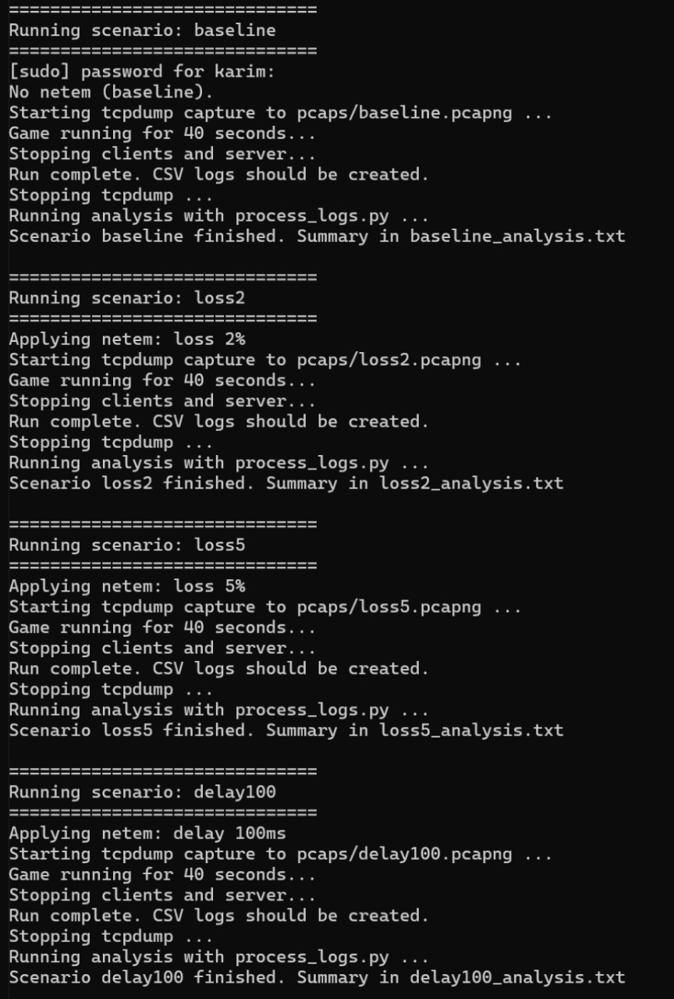
Figure (4): Netem Output

6.3 Metrics Collected
- Latency: recv_time - server_timestamp
- Jitter: Variance in packet inter-arrival times
- Position Error: Euclidean distance between server (ground truth) and client perceived state

6.4 Automation
- process_logs.py interpolates timestamps and calculates spatial error.
- CSV outputs for analysis.

7.0 Example Use Case Walkthrough

Server Log
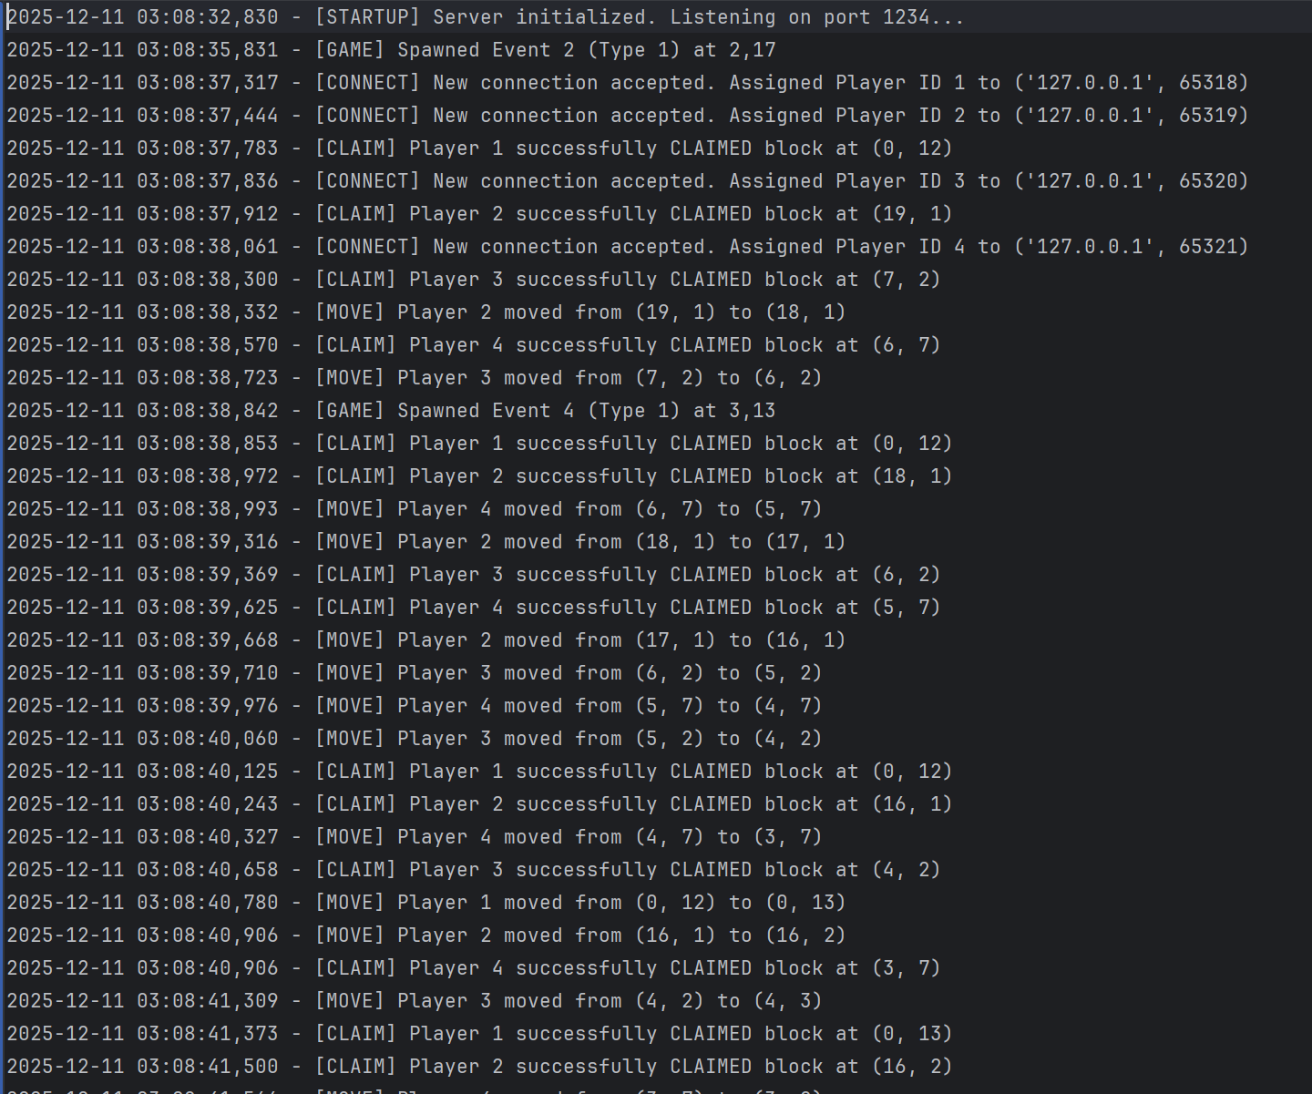
Figure (5): Server Log Output

PCAP (Wireshark)

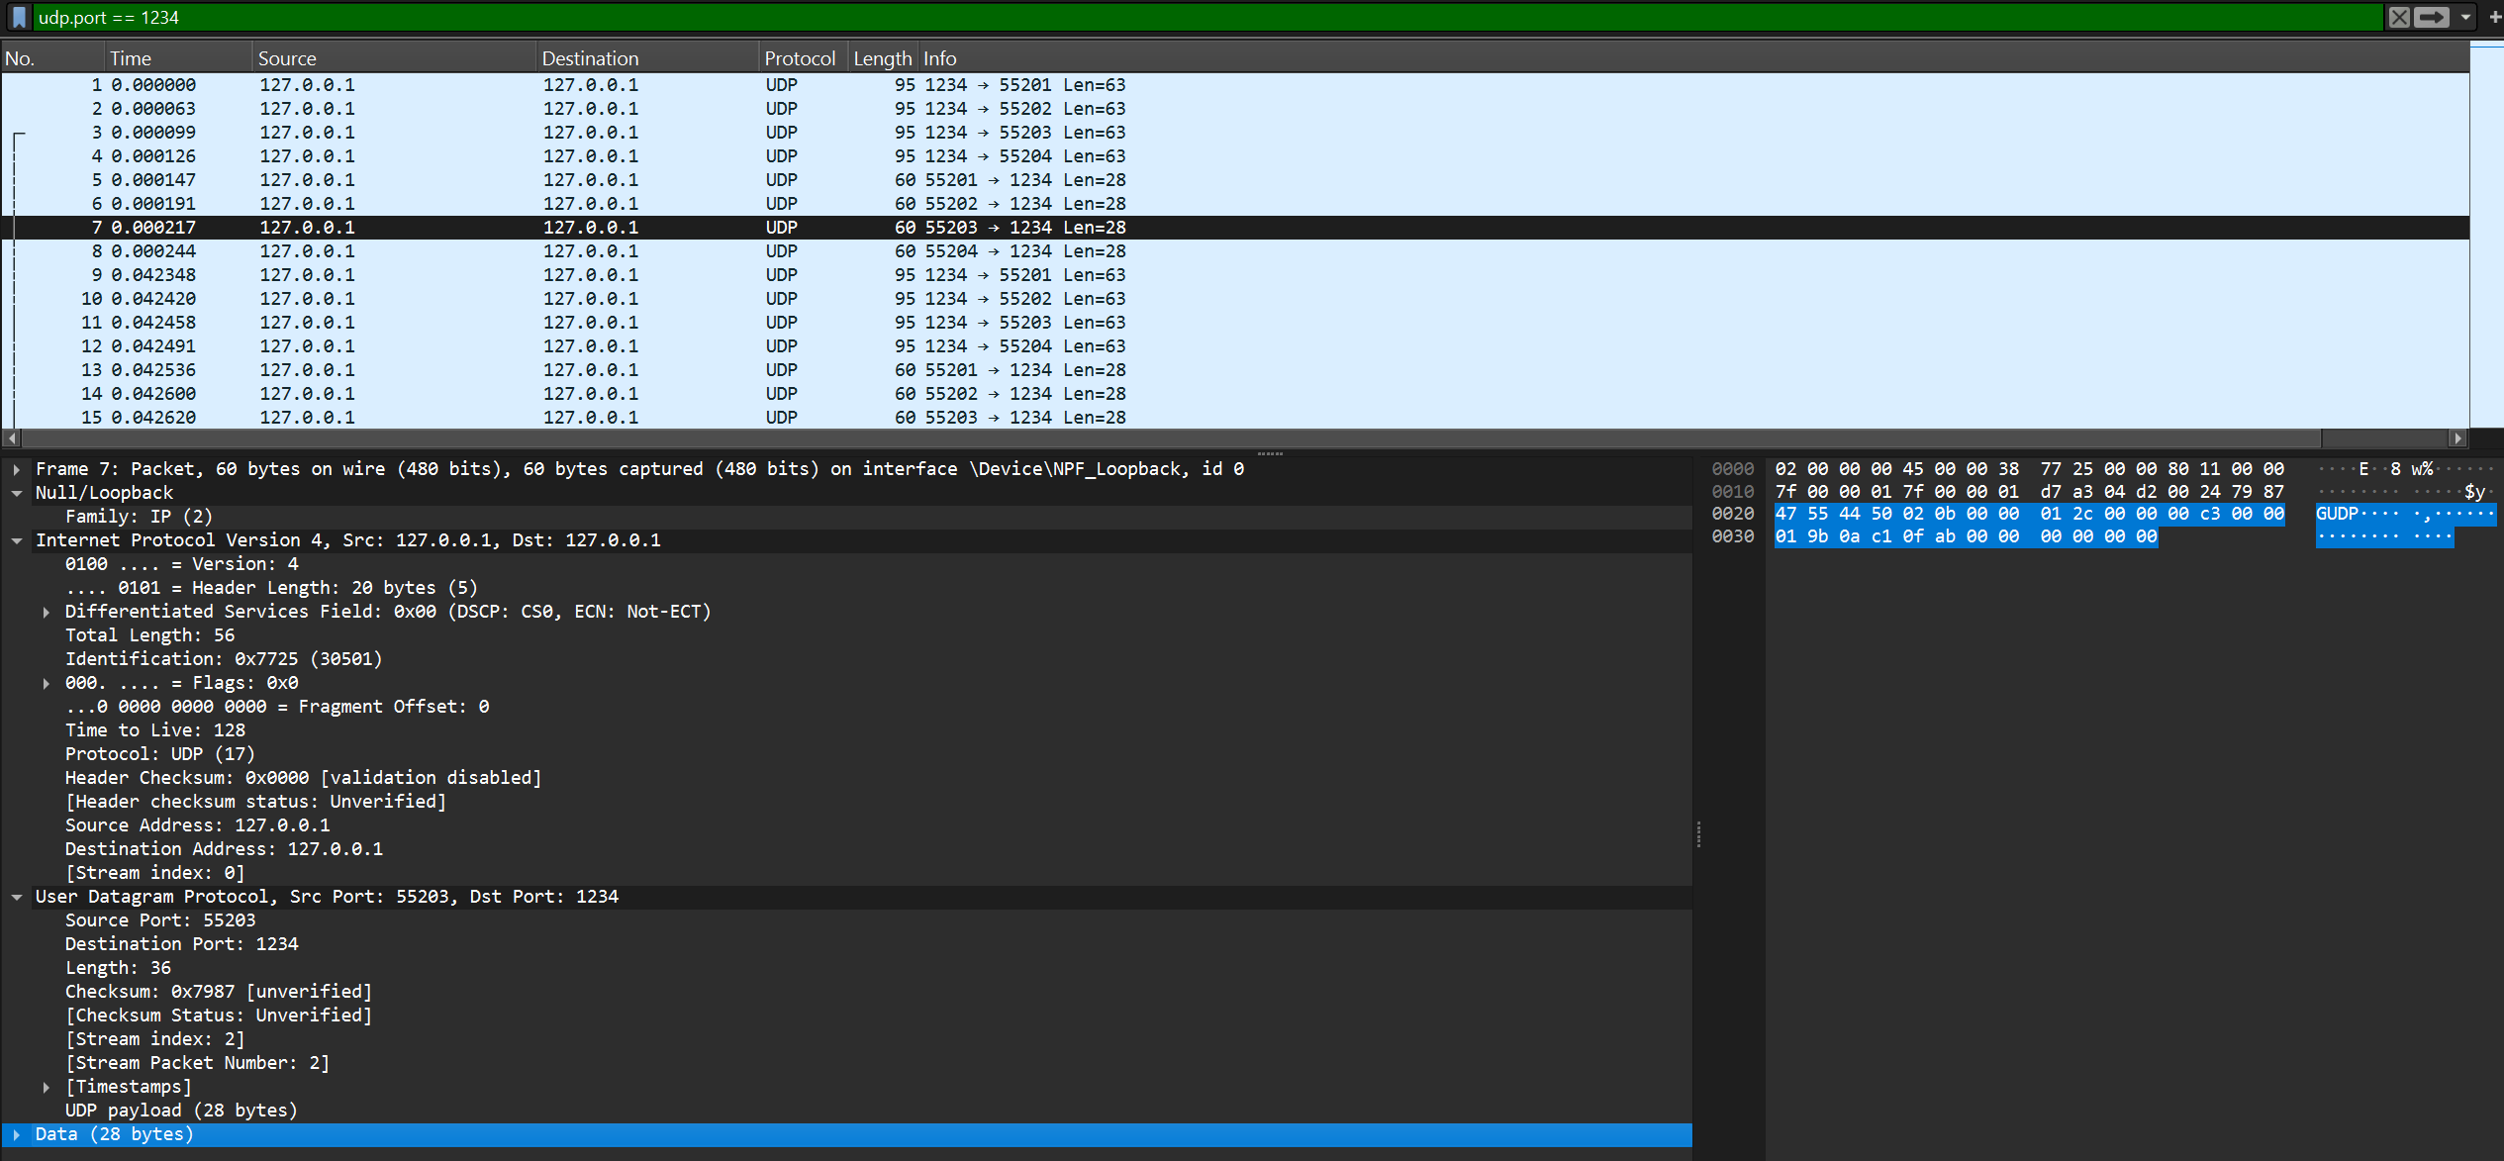
Figure (6): Wireshark Screenshot

